Purchase and Setup instructions for SWVPS
(Sept 15, 2014)

Our team recommends a Virtual Private Server (VPS) that works well for only $18.00 a month. Because trading in the market requires a platform that is open and active 24 hours a day, a VPS is the only safe way to do this.

1. Go to http://swvps.com. Find the WVSP-1 /Windows and click More Info.

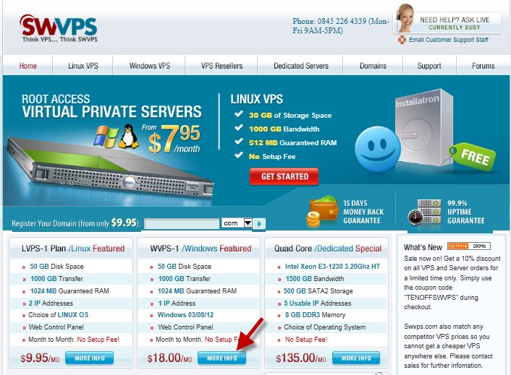

- When the page appears, review what you’re getting with the $18 WVPS-2 Plan (note the change from -1 to -2) and click Order Now.

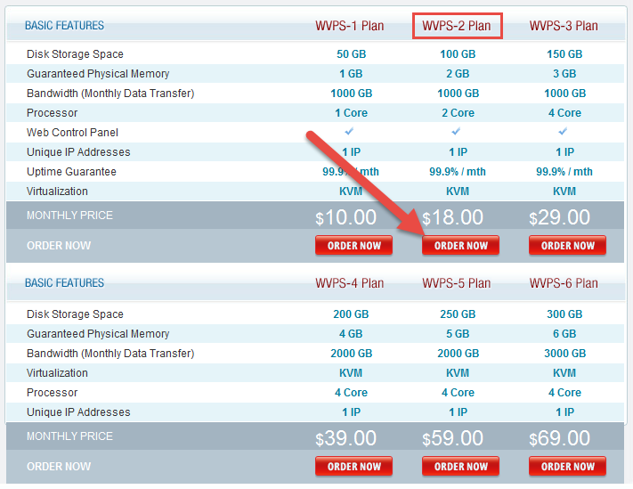

- Choose the No Hosting Panel for FX, the Texas Network and your Windows 2003 or 2008 operating system, then click Next.

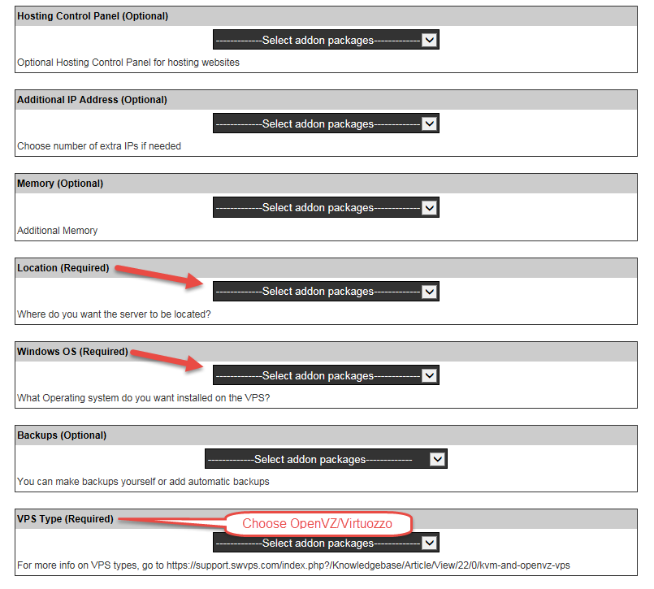

- When the Cart Contents window appears, click PROCEED TO CHECKOUT. Discounts are available if you purchase 6 months or more in advance.
(Buy 1 year, get 2 months free)

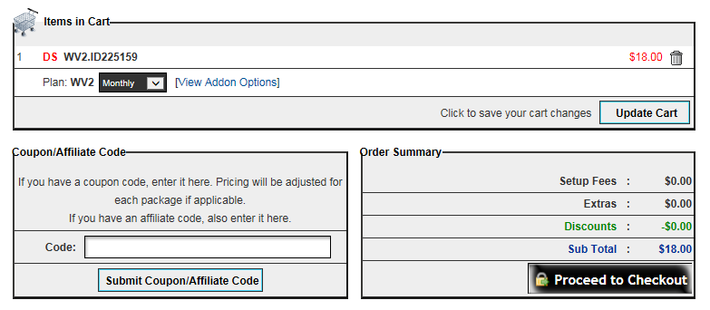

If you don’t already have an account, click Create New Account. Then choose your method of payment and click Submit.

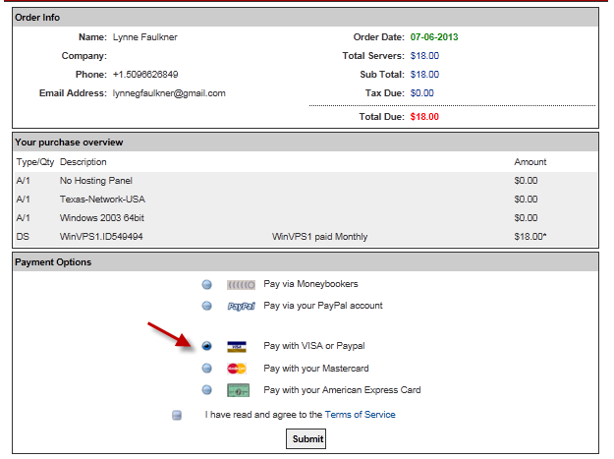

After your purchase, you’ll receive an email that indicates that your VPS has been set up (it could take up to 48 hours to receive it).

While you’re waiting for that email, SWVPS has some tutorial videos that will instruct you on things you will need to know, like how to upload files from your PC to the VPS.

Tutorials: in the back office, under Help & Info / Support Center/ Knowledgebase/ Windows VPS/ Forex Trading. Or click here:
http://support.swvps.com/index.php?_m=knowledgebase&_a=view&parentcategoryid=15&pcid=2&nav=0,2

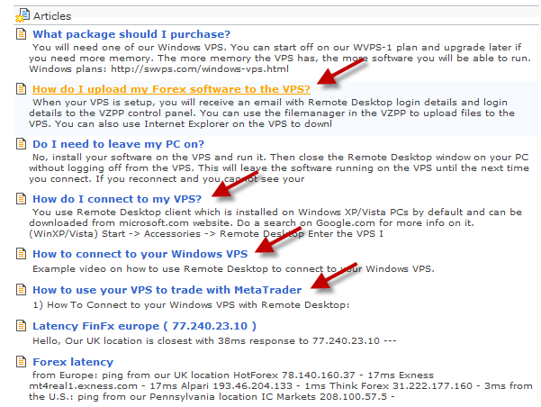

The email you receive from SWVPS Customer Support will contain your account information, including your Main IP Address (URL), Username and Password, which you need to connect and login to your new VPS. (this email is also archived in the Email Archive of your SWVPS Members site in case you misplace it:
https://secure.swvps.com/aLogIn.php

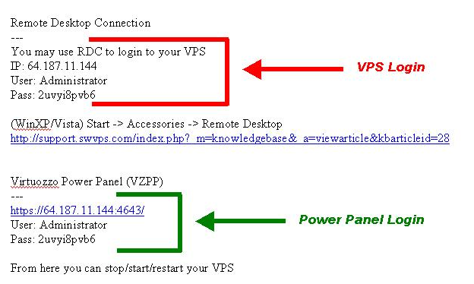

To create a connection to your VPS from your PC,

- left click the Start button in the lower left corner of your screen,
- highlight All Programs, Accessories,
- right click Remote Desktop Connection (if not in Accessories, look in Communications)
- highlight Send To, left click Desktop (create shortcut)
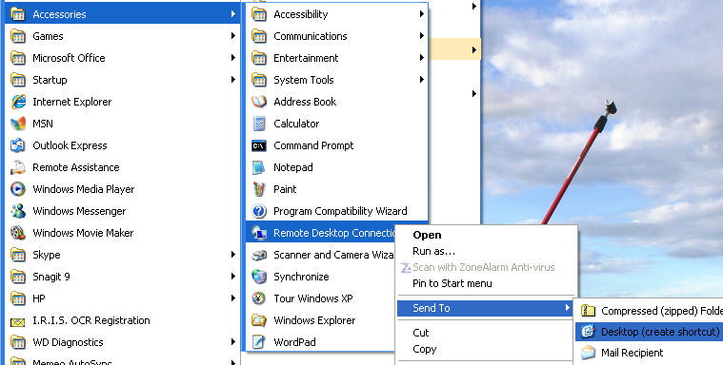

To access the VPS, click the icon on the desktop.
- Right click on the icon, click Rename, then name it SWVPS
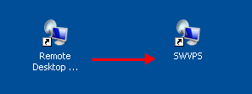

- Click the SWVPS icon and enter the Main IP address (from the Email) into the Computer name field
- Click on the Options button:

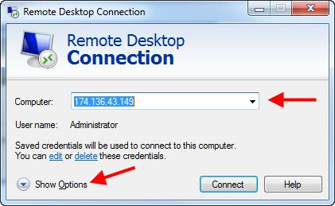

- Click the Advanced tab.
- Click the drop down arrow and select Connect and don’t warn me option
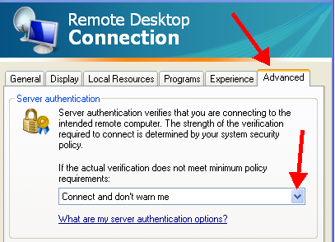

- Click the Experience tab.
- Click the drop down arrow and select LAN (10 Mbps or higher). This will cause all of the “Allow” boxes to be checked. Check “Reconnect if connection is dropped”

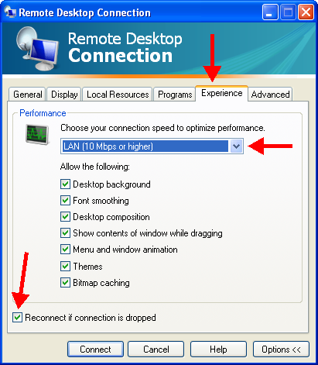

- Click the Local Resources tab.
- In the Local devices section of the window, make sure the Printers and Clipboard boxes are checked. This will allow you local (PC) printer and clipboard to be available to your VPS.
- Click on the More… button.

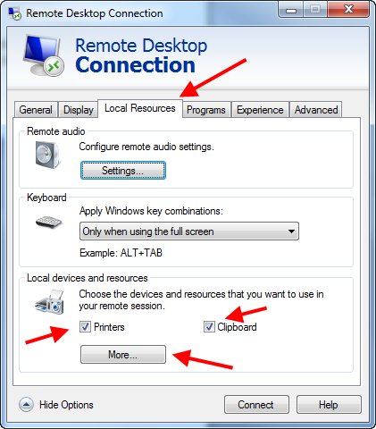

- Check the C: box. This will allow your PC’s disk drive to be seen from your VPS. This is very important because it provide an easy, drag and drop way to upload files to your VPS. Check any other drives that you want to be available to the VPS, like maybe a dvd drive to backup some files.
- Check the Supported Plug and Play devices box.
- Click OK.

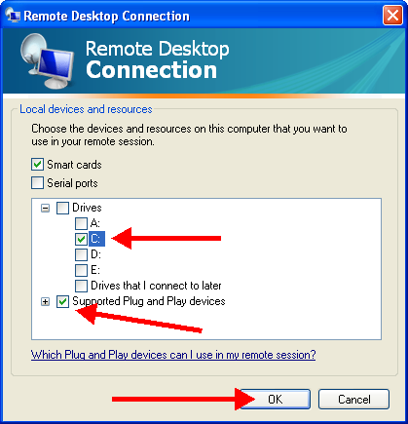

- Click the General tab.
- Enter “Administrator” into the User name field.
- Uncheck the box for Always ask for credentials.
- Click Save.
- Click Connect.

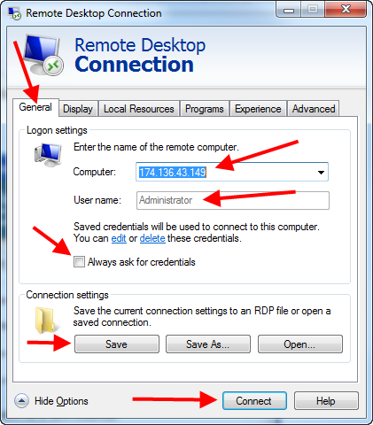

- Browse for a folder where you wish to save the connection file
- Give it a File name, like SWVPS?
- Then click Save.

You will be presented with the following window:

- Enter your Password (from the email),
- Click OK. (The next time you login, it should remember your User Name and Password and log you in automatically)

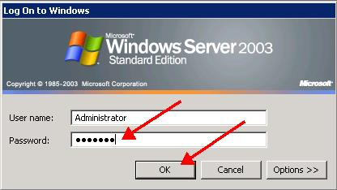

You are now connected to your VPS and should be able to see the VPS Desktop.

Now you need to move some files onto the server, and we can start by loading a demo platform from FXDD (or whatever broker you are trading with).

Click Start, All Programs, Internet Explorer and type in the team site address to download FXDD’s demo platform: http://teamforex.info. Save the platform program to your desktop, so you can open multiples if needed.

Security: When using your internet browser on the VPS, the security procedure causes a window to pop up.

- Click on Add

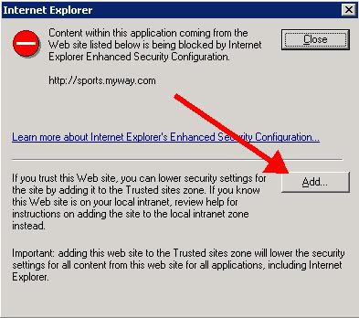

- Then click Add again
.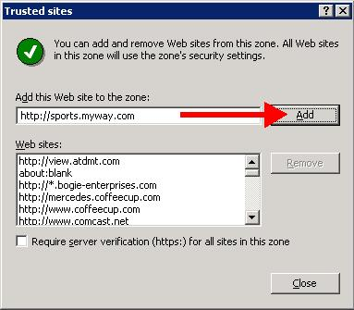

If there are other sites that you know you’ll be going to, you can add them now also. (like http://teamforex.info ) Then click on Close.

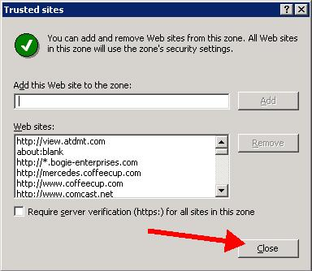

An easy way to upload files is to use Windows Explorer (the file manager, not the browser). Right click Start, in your VPS window then left click Explore. The example below shows the VPS hard drive and your PC’s hard drive. Expand the folders and you can drag files from your PC to your VPS, and back.

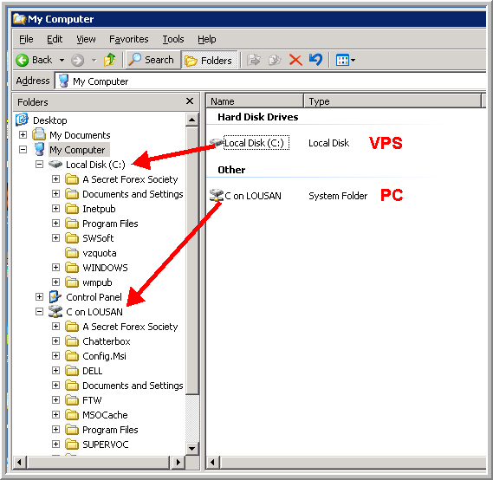

- If there is no mouse movement on your VPS screen, your Remote Desktop Connection (RDC) will time out. This duration seems to vary—sometimes every 10 minutes, sometimes several hours. Just login again. Even though your connection is lost, the programs running on your VPS will continue to run uninterrupted.

- When you’re ready to end your connection, you can click on the X on the VPS Title bar or you can right click on the RDC (your URL) tab on your PC’s (not your VPS’s) task bar and then click Close.

- DO NOT exit Windows on your VPS via the Start button (Log Off or Shut Down) as this will shut down your MT4 platform and thus your active trades, EA’s or robots. It’s the VPS connection, not Windows, that you want to terminate.

- Occasionally, SWVPS will need to do some maintenance and will need to shut down the servers, which means your MT4 platforms are shut down also.
- To have your MT4 platform re-start when windows re-boots, add the C:/Program Files/MT4 platformname/terminal.exe program to the Windows Startup menu.
- On the team site, www.TeamForex.info, under Cool Tools, there is a program, Startup Control Panel, which will allow you to easily do this. Download and install the program, then go into your Windows Control Panel and click on the View x86 Control Panel Icons:

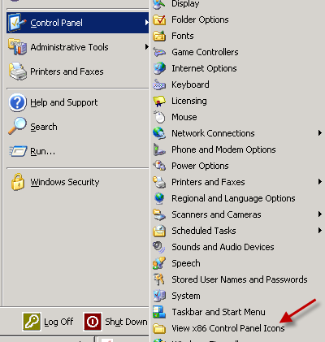

Next, click on the Startup (user) tab, right click on the white space in the window and then left click on the New… button that appears:

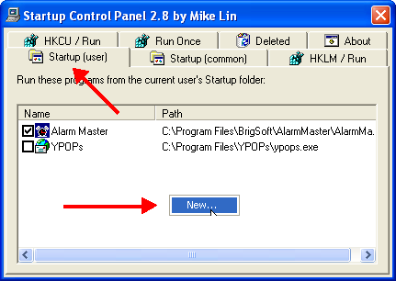

In the Program Properties window that appears, enter a name for the program to be added and then click on the Browse Files button:

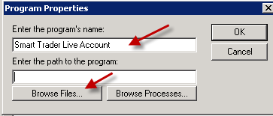

Browse for the terminal.exe file for each platform you wish to reboot and add it to the Startup list, highlight the file name, and click Open:

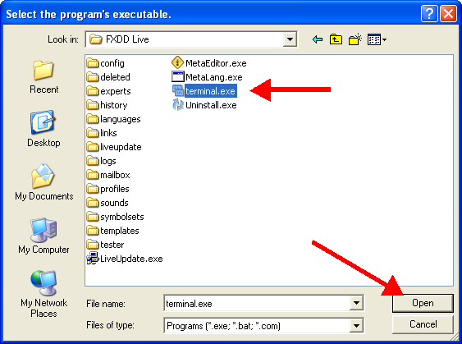

Click the OK button in the Program Properties window.

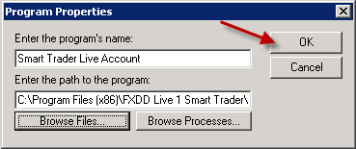

Make sure the little box is checked, and then click to exit the window and you’re done.

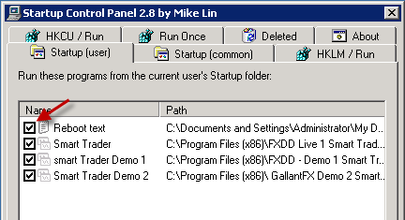

Sometimes it’s not easy to tell if your VPS has re-booted. To know for sure, you can create a text file, call it Reboot.txt and save it in My Documents, then add it to your Startup list in the same manner as above. When the system re-boots you’ll get a window that looks like this:

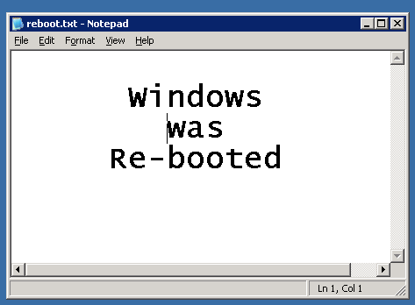

There may be other windows covering it up, so look on your task bar when you login:

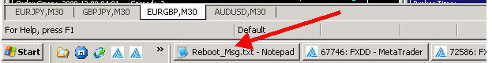

By default, Windows Server 2003 has Sound disabled for Remote Desktop Connection, so you will probably find that you have no sound coming from the VPS and that you are frequently losing the connection to the VPS. Here are the instructions for getting Getting sound via Remote Desktop Connection and Keeping your session open, so you don’t have to keep logging into your server:

- Login to your Server

- Go to START, CONTROL PANEL, ADMINISTRATIVE TOOLS, TERMINAL SERVICES CONFIGURATION.
- Left click CONNECTIONS, then in the right hand window Right click RDP-TCP, then left click PROPERTIES.
- Click the CLIENT SETTINGS tab and make sure AUDIO MAPPING is
un-checked. If not, then un-check it.
- Next click the Sessions tab, check the first “Override user settings box and choose your session limits. (Note: this portion just relates to your Remote Desktop Connection, and does not shut down your platforms or your server).
- Choose times that you would like the connection to stay open for End a disconnected session, Active session limit and Idle session limit.
- Click "Apply”, then click “Close"
- Close all windows (all platforms)
- Restart the VPS by clicking START, then choose SHUTDOWN , select RESTART from the dropdown menu under “What do you want the computer to do?”, then type any word in the Comment box and click OK.
- After disconnection close any Remote Desktop popup windows and wait about 1 to 2 minutes to connect again using your shortcut.

Now when you log back in you will have sound on your server, and your session will remain open. For all future sessions, NEVER use the ShutDown feature, only use the X in the top of the window to close the server.

If it should happen that your VPS still disconnects frequently, then perhaps the Windows Screen Saver is turned on. Make sure is set to “None”.

- Click on the Start button on your Task bar
- Highlight Control Panel
- hightlight Display
- Click on the Screen Saver tab
- In the Screen saver block, select (None) from the drop down menu
- Click Apply
- Click OK
- That's it. Close the open windows and you're done.

